Cryptography:

**1)b. Sniffers**

* + Program and/or device that can monitor data traveling over a network
* **Man-in-the-Middle**
  + Attacker sniffs packets from the network, modifies them, and inserts them back into the network

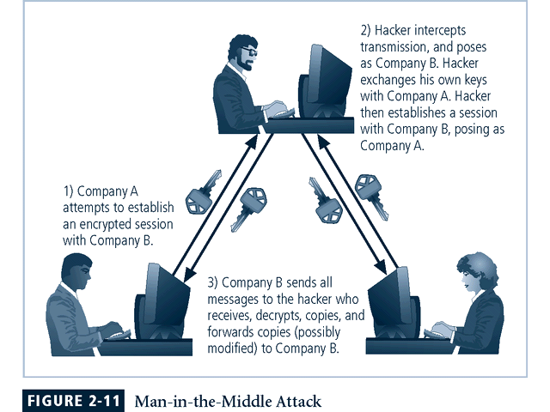

* **Spoofing**
  + technique used to gain unauthorized access whereby the intruder sends messages to a computer with an IP address indicating that the message is coming from a trusted host

